**The Validation Process for each column**

The validation process was done using Microsoft Excel. The steps for validating each column are as follows

* Sales Method: A list was created in sales methods by copying the types of sales methods in a singles cell. Furthermore, data validation was selected under the data tab, allow settings was changed to list, and the list of sales methods were inputed.
* Revenue: The maximum and minimum values were derived using the MAX and MIN functions respectively. Data validation was selected under the data tab, allow settings was changed to decimal, and the maximum and minimum values were inputed.
* Client Category years: A list was created in client category years by copying the types of sales methods in a singles cell. Furthermore, data validation was selected under the data tab, allow settings was changed to list, and the list of sales methods were inputed.

**The Cleaning Process for each column**

The cleaning process was done using Microsoft Excel. The steps for cleaning each column are as follows

* Week: The week column was sorted in ascending order by doing a right click on the week column and selecting “sort smallest to largest”. This process arranged the week column from week 1 to week 6.
* Sales Method: In the sales method column, the ‘&’ sign in between email and call was replaced with ‘and’ by using the find and replace function on the Home tab.
* Revenue: This column was rounded up to 2 decimal places by clicking on ‘General’ under the Home tab, then selecting more number format, further select number and change to 2 decimal places. In addition, the currency was changed to dollars under the Home tab.

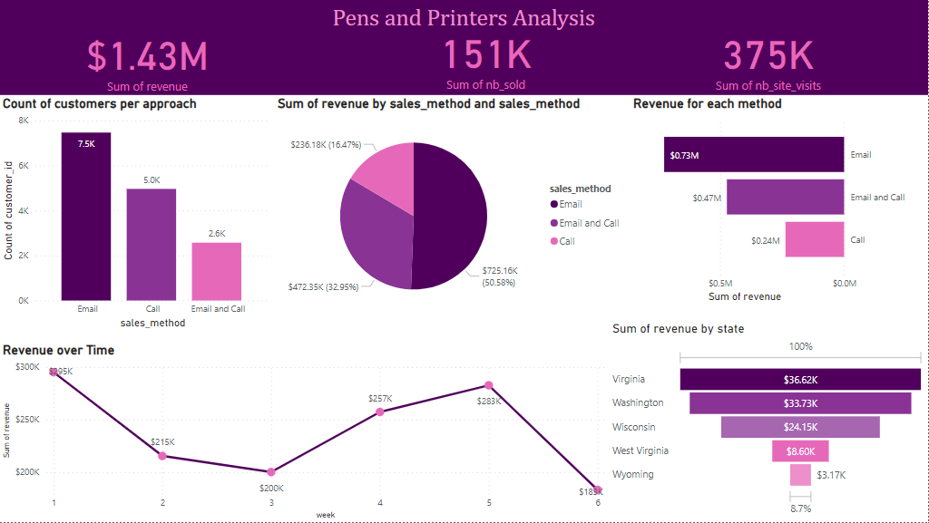

**Figure: Dashboard for pens and printers analysis**

From the dashboard shown in the figure above, the following answers to the questions asked can be derived

1. Question: How many Customers were there for each approach?

Answer: The column chart shows the count of customers per approach. Email approach had 7,500 customers, Call approach had 5,000 customers and Email and Call approach had 2,600 customers

1. Question: What was the spread of the revenue overall and for each method?

Answer: The total revenue is $1.43Million. The bar chart shows the spread of revenue for each method. Email approach gave $0.73 million, Call approach gave $0.47million and Email and Call approach had $0.24 million

1. Question: Was there any difference in revenue over time?

Answer: Yes there was difference. The line chart shows the difference in revenue over time

1. Question: Based on the data, which method would you recommend we continue to use?

Answer: The Email sales method is recommended because it brought more customers and in turn yielded more revenue

Summary: The three different sales method are profitable but the Email sales method is more profitable.

Recommendations:

* The company should invest more in Email sales method as it is more profitable than the other sales methods
* There should be more focus on Virginia, Washington, Wisconsin, West Virginia and Wyoming because that are the top 5 countries with the highest revenue generated.